Meeting record
Subject | Eco Park Community Liaison Group
Date | Monday 22 June 2026
Location | Eco Park, 3rd floor
Recorder | Eleanor Cottrill

Present
Name | Initials | Organisation | Title / Role
Ken Snaith | KS |  | Resident, CLG Chair
Peter Vidler | PV | SUEZ | AE Operations Manager
Johanna Camara-Gal | JC | SUEZ | AE Technical Plant Engineer
Malcolm Robertson | MR |  | Resident
Gareth Swain | GS | SUEZ | Regional Manager
Natalie Saenz | WH | SUEZ | Corporate Affairs Manager - South
Carl Phillips | CP | Shepperton RA | Resident
Andrea Koskela | AK |  | Resident
Jodi Johnston | JJ | Surrey County Council | Contract Performance Manager
Sandra Dunn | SD | Spelthorne Borough Council | Mayor of Spelthorne
Karen Howkins | KH | Spelthorne Borough Council | Cllr. - Laleham and Shepperton Green
Jasmine Bressler | JB | SUEZ | Environment and Industrial Risk Advisor
Paul Thompson | PT |  | Resident
Eleanor Cottrill | EC | SUEZ | External Affairs Executive

1.0 | Welcome and apologies
NS welcomed members to the meeting

Apologies for absence were received from Nigel Spooner, Buddhi Weerasinghe, Derek Ferguson, Paul Barnett, Jason Benfield, and Richard Watkins.

New members to the CLG
EC, PV, and the CLG members introduced themselves

Congratulations were given to SD on her appointment as Mayor of Spelthorne.
Discussion of new political structures followed and suggestion of including new shadow councillors in invitations going forward.

JJ confirmed roles may not yet be determined and that council staff will not be interacting with the new shadow authority until later in the year.
2.0 | Approval of minutes from previous meeting and matters arising
2.1  2.2 | The minutes of the meeting held on 23 March 2026 were approved.  Paragraph 3.2  AK requested clarification of paragraph 3.2 in the previous minutes regarding how electricity is generated by the facility, what parasitic load means and how the electricity is distributed as the answers to these questions were not included in the previous minutes.  PV confirmed that parasitic load is the amount of energy needed to run the site which is drawn directly from the energy generated.  AK Referenced the 2024 report (which is the most recent available on the website) and that the parasitic load is listed as 50% and asked if that was normal.  GS Added the discussion to AOB  Paragraph 4.1  SD enquired about the results of GS previous action to review the access controls at the CRC to prevent queuing  GS confirmed that both entry lanes into the CRC could not be used to access site safely, the current process of two lanes filtering into one is the safest option. This requires visitors to use both lanes while queuing and filter appropriately where signposted.

3.0 | Operational update
3.1 | Gasification  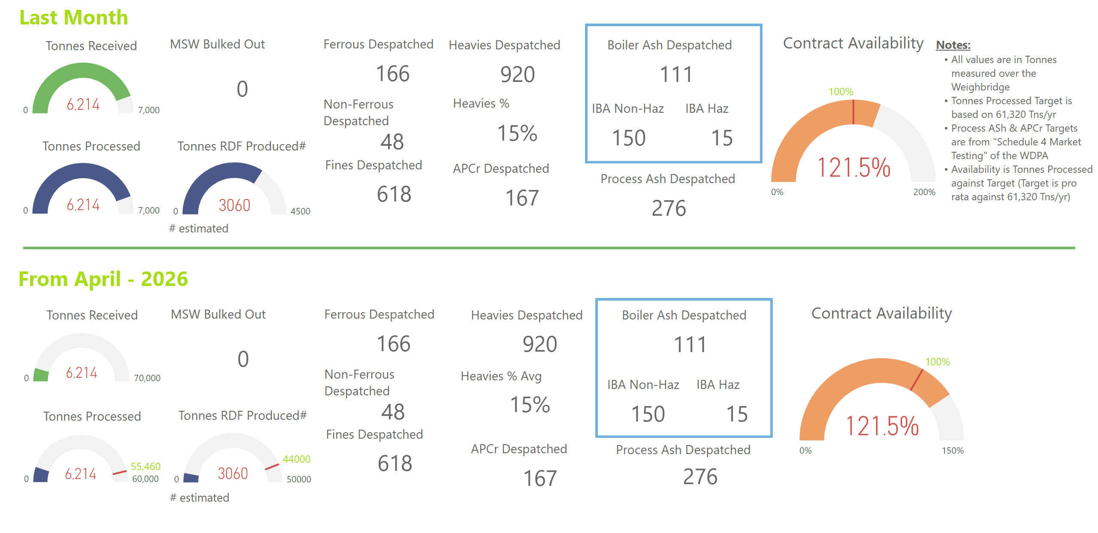  Figure 1  PV reported that the gasifier is performing well.  PT queried the amount of material processed through the gasifier and PV confirmed that it is the same as the tonnes of RDF produced, 3060.  KH enquired about the impact of the fire previously covered in the local news  PV confirmed there was no operational impact as the plant was already offline for planned maintenance  GS explained that the cause of the fire was planned hot works on the conveyor which accidentally ignited a small build up of waste in the crevices around the work. The fire brigade was involved due to the difficult access to the space rather than due to the scale of the fire as firefighters have specialist tools for confined space entry. The fire was small and had minimal impact on the conveyor, all damage was repaired within 24 hours.  The CRC was closed as the fire brigade blocked the entry road to access the building effectively.  KS requested confirmation of which fire due to hearing reports of more than one  GS confirmed that discussion of the other incidents was planned later in the agenda and PV confirmed there has been a fire at both the CRC and EcoPark and that the explanation above was for the EcoPark incident  GS moved the discussion onto operation of the gasifier following shutdown and PV confirmed the plant has been running well except for an incident the previous week which he went on to explain that some of the refractory (heatproof material that lines the gasifier) fell and caused a blockage. It was a known issue, the damage was observed during the most recent shutdown and repair works were scheduled for September, unfortunately the repair was required before the planned maintenance but is now complete.  GS added that the gasifier processed 60,000 tonne in the previous year which is above designed throughput and demonstrated how well it was working  MR enquired if the 60,000-tonne mentioned by GS was the amount of material through the gasifier  GS explained that it is the material received and processed through the mechanical pre-treatment plant and requested the amount of material through the gasifier be added to the minutes  PMN; The amount of material gasified in 2025 was 38,878 tonnes.  Emissions  NS confirmed emission performance remains well within permitted limits and that the dips observed in September are linked to the planned outage.  KH enquired about the ammonia increasing trend raised in the previous minutes and if it had been looked into  PV reiterated that it could be due to monitoring device calibration  JB confirmed that RW had looked into this since the last meeting but no clear cause was identified, levels have reduced in May and remain within permit compliance | SUEZ

3.2 | Anaerobic digestion  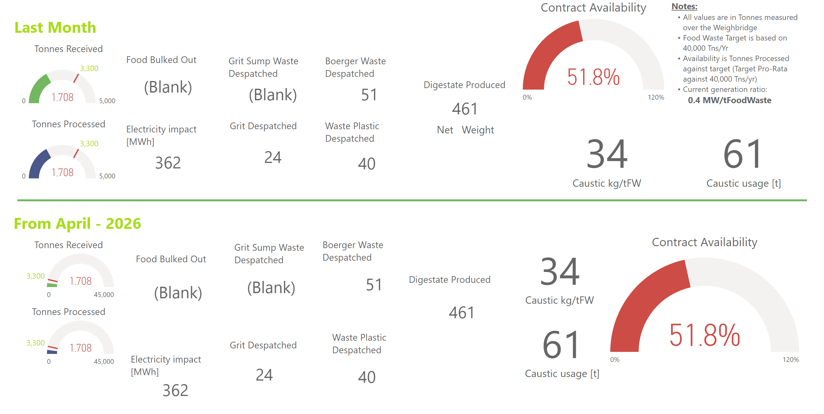  Figure 2  PV explained that the AD has been on reduced tonnage for a planned de-grit of one of the pre-treatment tanks which has lowered the amount processed to half of its normal capacity. The de-grit is removal of grit like material (made up of bones, seeds, eggshells, etc) which builds up gradually in the tank despite efforts to remove it earlier in the process. It occurs approximately every 5 years and takes approximately 1 month to take the tank off-line and 6 weeks to bring back on-line to avoid shocking the biological anaerobic digestion process.  KS enquired about material diversion  GS confirmed that SUEZ has contingency arrangements and that during the reduced availability food waste material has been diverted to contractual contingent sites  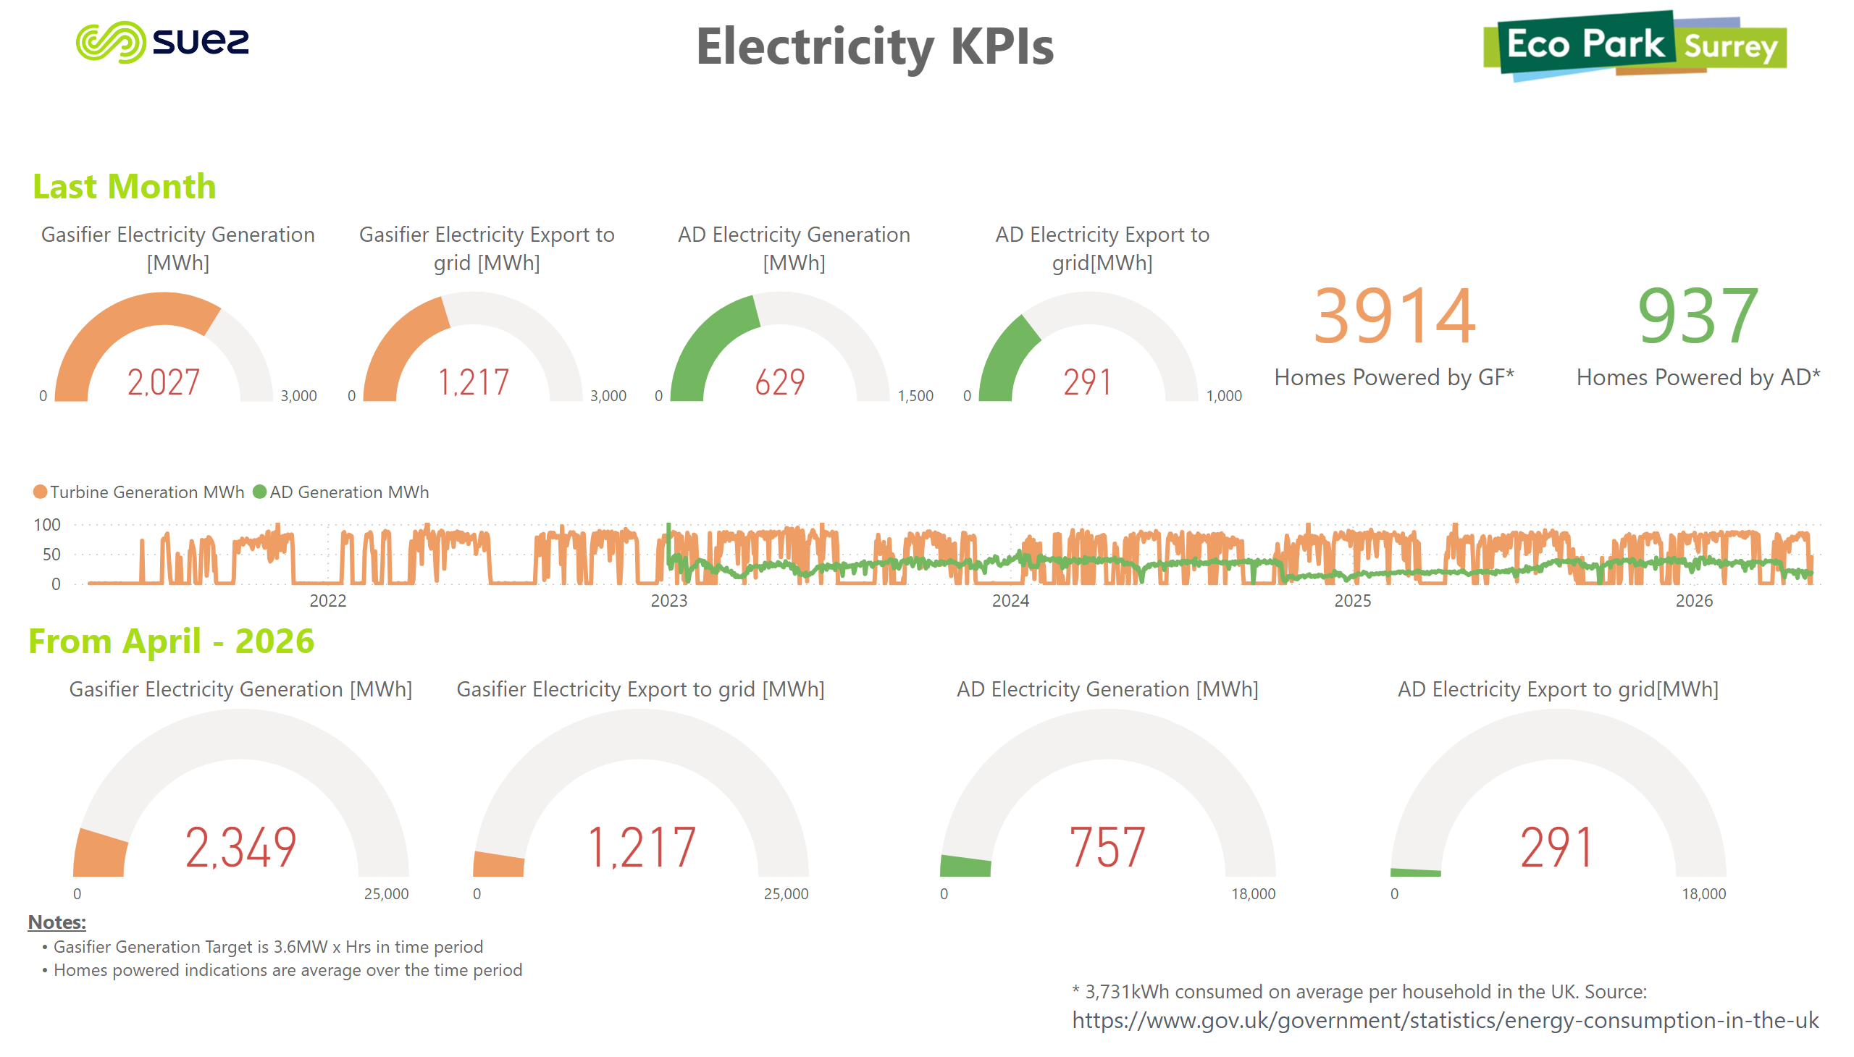  Figure 3  GS re-started the discussion of parasitic load  PV confirmed that electricity is generated by the gasification facility via use of the heat from this process to create steam which runs a turbine. Electricity is generated by the AD plant via the generation of methane which is in turn combusted in a CHP engine.  GS confirmed parasitic load sits around an average of 50 % but that as export from the AD is currently down around 50 % due to the lower amount of material being processed parasitic load appears higher. However, the parasitic load remains the same the site is just generating less energy than normal.  MR enquired if energy generation was considered for the whole plant  GS confirmed that the AD and gasifier are treated as two separate streams which generate their own energy separately. Any remaining energy is sent to the grid.

3.3 | Complaints  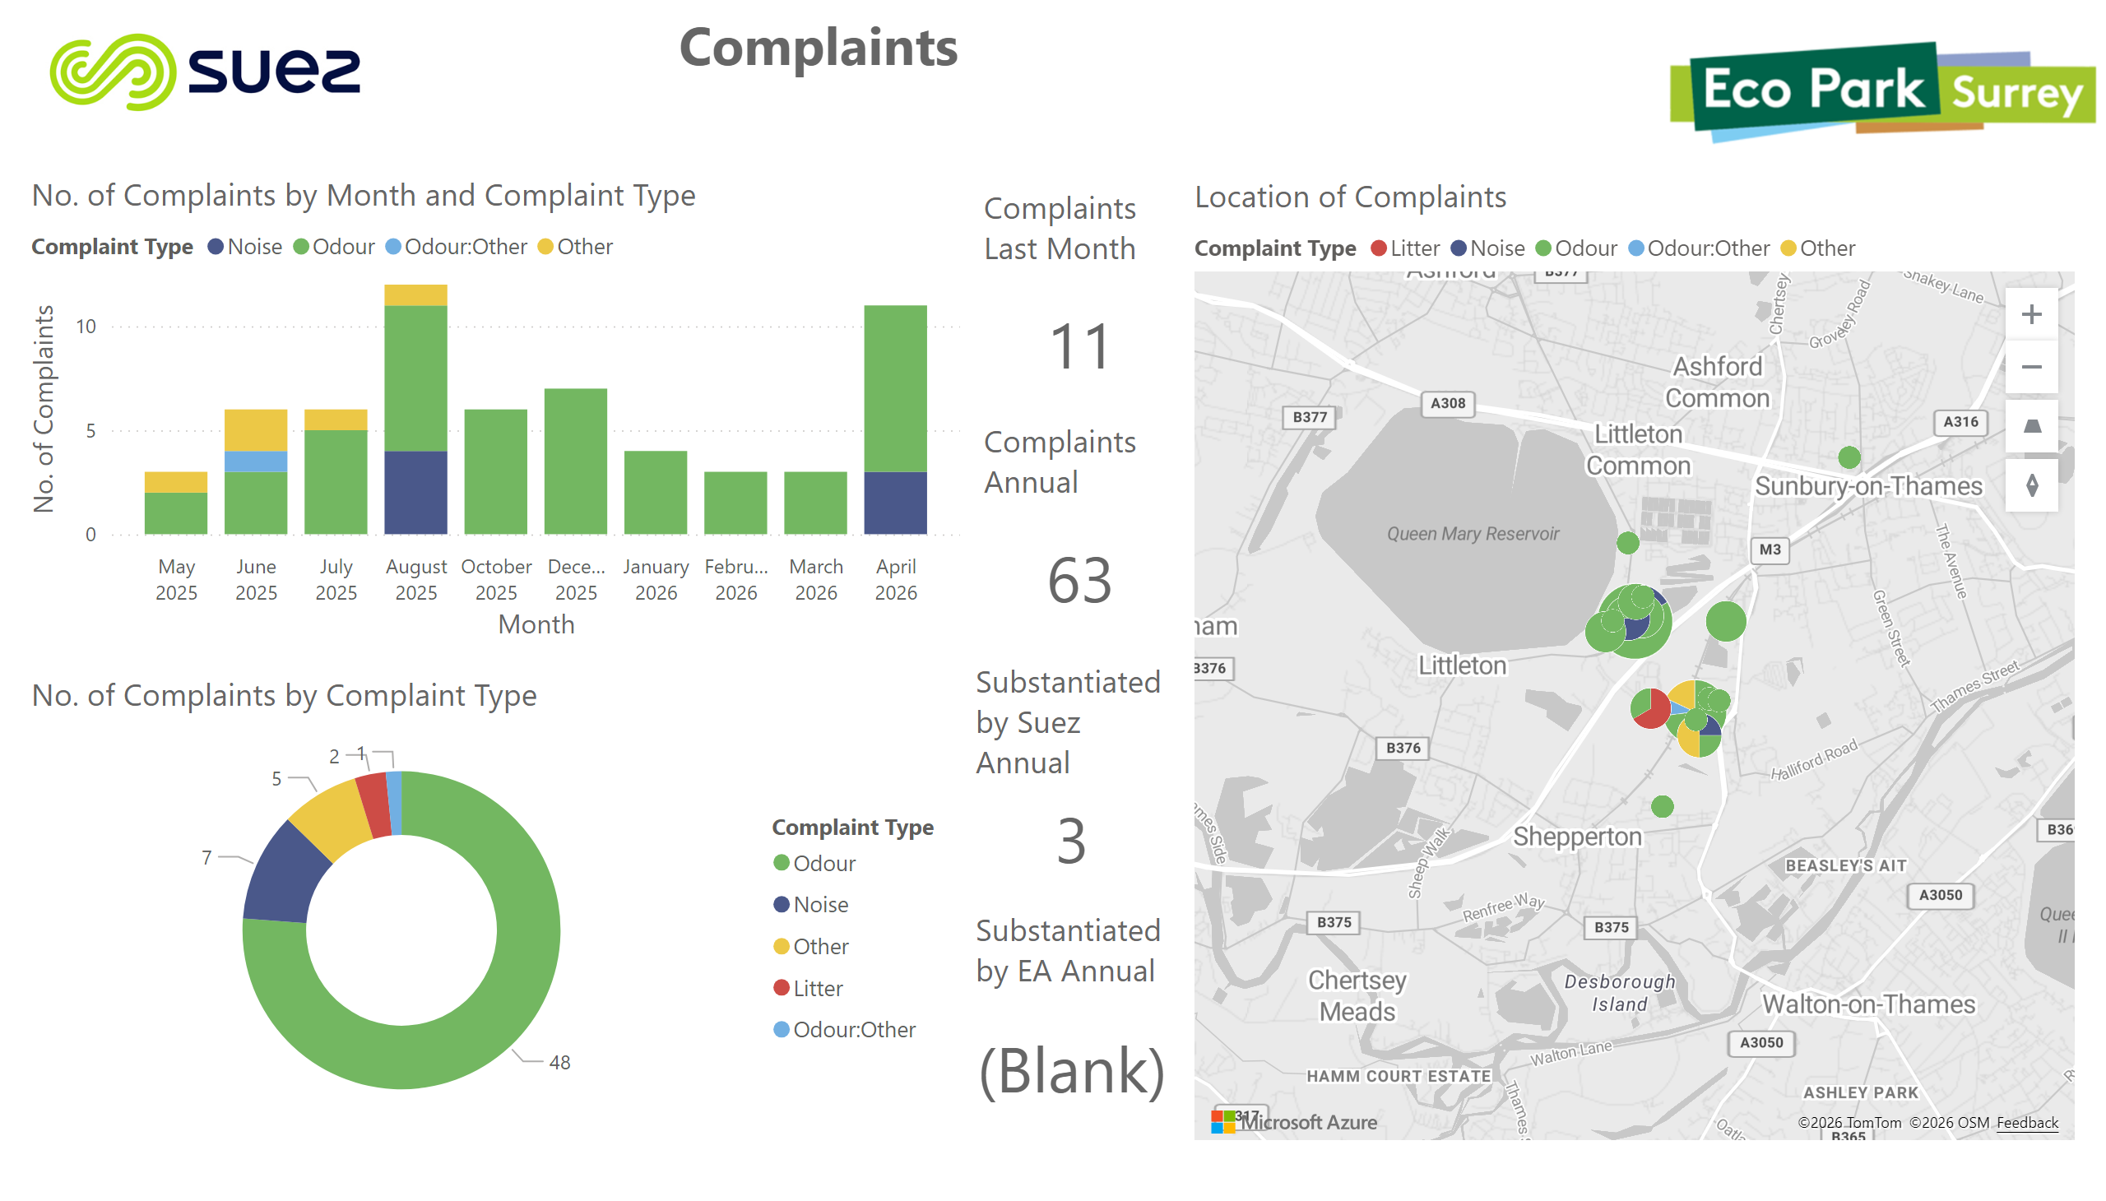  Figure 4  NS gave an overview of the complaints and confirmed there were 3 noise complaints linked to fire alarms. 2 of these were due to the shredder alarm on the pre-treatment plant in April. The other complaint was reported at 4:30 am but on review, the alarm sounded at 3:30 am so the complaint was not substantiated.  In April there were 7 odour complaints during the de-grit works, the site was otherwise operating normally at the time of the complaints, and all odour control systems were in operation. On the 17 April there was an unannounced visit from the EA but they were unable to detect any malodour. There was a further noise complaint in May which was due to the fire alarm sounding overnight due to a fire, and 2 further odour complaints which were investigated, however there were no issues on site and the complaints were therefore not substantiated.  CP enquired if odours are observed more frequently in hot weather  PV explained that due to the odour suppression and other control measures in place there shouldn’t be additional odour during hot weather. He also explained the additional measures applied during the de-grit such as application of odour suppression specific to ammonia. He also suggested that it could be due to more people spending time outside in hot weather and hence increasing likelihood of observing odour.  GS confirmed that the collection vehicles do produce more odour in hot weather  CP agreed that hot weather is outside of our control  GS raised the report recieved from the EA visit  JB confirmed that there were some scores for non compliances. However, the officer did not follow the appropriate measures guidance for assessing noise so that score was discounted. There was also a pause in fly counts completed by the external contractor which has now resumed as normal. There was additionally a score for failure to clean the filters in AD as requested by the EA; this has now been completed.  AK enquired if the oversensitive alarm issue has been resolved  GS confirmed that is has been resolved and that the situation with the alarms is greatly improved.  JB also confirmed that external sounders have been amended so that they are no longer audible between 9.00 pm and 6.00 am.
4.0 | RBF and CRC Operations
4.1 | GS confirmed there have been two fires at the Transfer Station (TS) which have both been attributed to batteries. There is an internal policy that ‘black bag’ material should not be moved several hours prior to the end of day, as movement may increase fire risk. However, one of the fires occurred at 11.30 pm which was a concern due to the lack of movement for many hours of this material before the fire. The incident was identified quickly and handled by the EcoPark team.  GS also referenced the recent BBC work on battery fires: Why batteries in our bins are a burning issue - BBC News  CP requested that there be no battery storage on site  GS explained that it is not the battery storage area that is the issue, but batteries incorrectly disposed of in black bag waste which cannot be seen and risk crush damage by the movement of this material by the loading shovel  CP expressed a greater trust in SUEZ teams than the local fire service and praised the Eco Park teams fast action to prevent spread  GS explained that the second fire occurred in operating hours and that both fires occurred in the same bay with the same cause. He also referenced the dust cart procedure – which is to tip their load wherever safe to be dealt with by the fire brigade.  GS also mentioned that the vape bin is working well but there are many other items containing batteries such as phones, e-bikes, and portable chargers.  PT enquired about the process for putting out battery fires  GS referenced the fire triangle (heat, fuel, and ignition) and that, if possible, the battery is removed from the surrounding waste which can act as a fuel. The battery and surrounding material is drenched in water. The recommendation from the fire brigade in a home setting is to place the bruised battery (term for damage) in a bucket of water for at least 2 days before proper disposal.  CP enquired about the amount of water used to put out a waste fire  GS explained that if caught early and removed from the waste pile a fire extinguisher is sufficient but that it must be caught within the first minute as it can catch so quickly, otherwise substantial amount of water could be used.  JJ added that the material must then also be quarantined and put on fire watch for 24 hours  KH enquired about council communications on the subject  JJ confirmed that all SCC boroughs have received the same communications packs but offered to see what information has gone out.  GS confirmed the importance of education and that lead acid batteries don’t cause as much of an issue as lithium batteries as people know how to properly dispose of them  JJ Confirmed that the comms provided did cover disposal routes but that it varies by local authority with some offering kerb side collections. However, SCC prefers recommending CRCs due to the potential risks with storing batteries in collection vehicles.  GS commended the work on CRCs during the hot weather and expressed SUEZ’ commitment to supporting employees who experience amplified heat due to the areas they work in (concrete radiating excessive heat). He requested patience in the hot weather and explained there may be some disruption.  KH enquired about the measures being taken to support employees during the heat wave  GS explained that hats, suncream, and water bottles are provided as well as additional breaks
5.0 | Community Engagement
5.1 | NS gave an overview of the community engagement, highlighting the recent website updates and the upcoming community fund launch. She also explained the recent Team Repair workshop and how they provide kits for children to learn to repair a gadget, the kits include the broken item and a detailed guide on how to repair it. They provide packs of these kits to be taken into schools and our partnerships and community engagement coordinator, Grace Leech, delivers them in workshop style sessions.  PT enquired about how we are pushing comms about community engagement beyond just the website to reach a wider audience  NS confirmed we have worked on several external press releases however are still building relationships with the local media so haven’t had much uptake from recently. She explained about working on a piece in partnership with SCC about the bike repair scheme and hoped that will be picked up externally.  SD suggested leaflets  GS explained the movement away from paper-based news  KH suggested Parish noticeboards  NS explained the project to introduce notice boards in the Revive Shops giving information on the projects funded. Measurements, branding and planning are underway with the plan to update Charlton Lane first and roll out to the other sites following customer feedback.  GS mentioned that he had seen something similar in Cornwall which we are looking to replicate in Surrey  NS confirmed there has also been an updated communications plan for the Revive Shop Facebook pages which will also act as a channel to push information  GS explained that as the processes are now in place the stories will speak for themselves  CP requested consideration of Surrey demographic and the limitations for those without social media access  NS advised she completed and advertisement for the Shepperton Fair and that in future it could be a good channel for sharing key information
6.0 | Questions
6.1 | NS confirmed no questions submitted in advance of the meeting  KS requested information on the post unitary authority arrangements  JJ explained that at the moment SCC staff have no access to the shadow authority so is unsure of the agreement moving forward. They are creating communications on the East and West split, but it is still unconfirmed, and the decision making is unclear.  GS confirmed that SUEZ and the authority would still work in partnership to maintain the service and the quality.  JJ is hoping for an update by the next meeting but also highlighted that the contract runs until 2029 so there will be no immediate change to service.  KH enquired about potential contract extension  JJ confirmed that there is a potential contract extension but that it will depend on the authorities  GS confirmed that there is a legal obligation to run the gasifier which commits both SUEZ and SCC. Any change in provision of this facility must be mutually agreed.  MR enquired how much waste that requires  GS confirmed 55,000 – 60,000 tonnes is the annual required amount processed through the mechanical pre-treatment (not gasified)  KM requested an update to the CLG terms of reference  GS confirmed that by the next meeting the outlook with the new authorities should be clearer allowing us to look into updating terms of reference  JJ couldn’t confirm attendance from shadow authority due to the reluctance from the current conservative administration to work alongside the incoming liberal democrats  KS suggested inviting them as observers or even local residents  GS advised that we are not in a position to allow or not allow and that it will require internal discussion. We can prepare but cannot progress any changes  JJ confirmed she will remain as the contract manager which will remain unchanged  GS added that considering the quality of service provided and its need it is unlikely that the contract will be a high priority for the incoming administration  JJ confirmed things may be clearer at the next meeting in October as the shadow authority are allowed access from September | SUEZ
7.0 | AOB
8.0 | Date of next meeting
 | Monday 19 October at 2pm has been agreed for the next meeting.

